100款改变历史的经典硬件

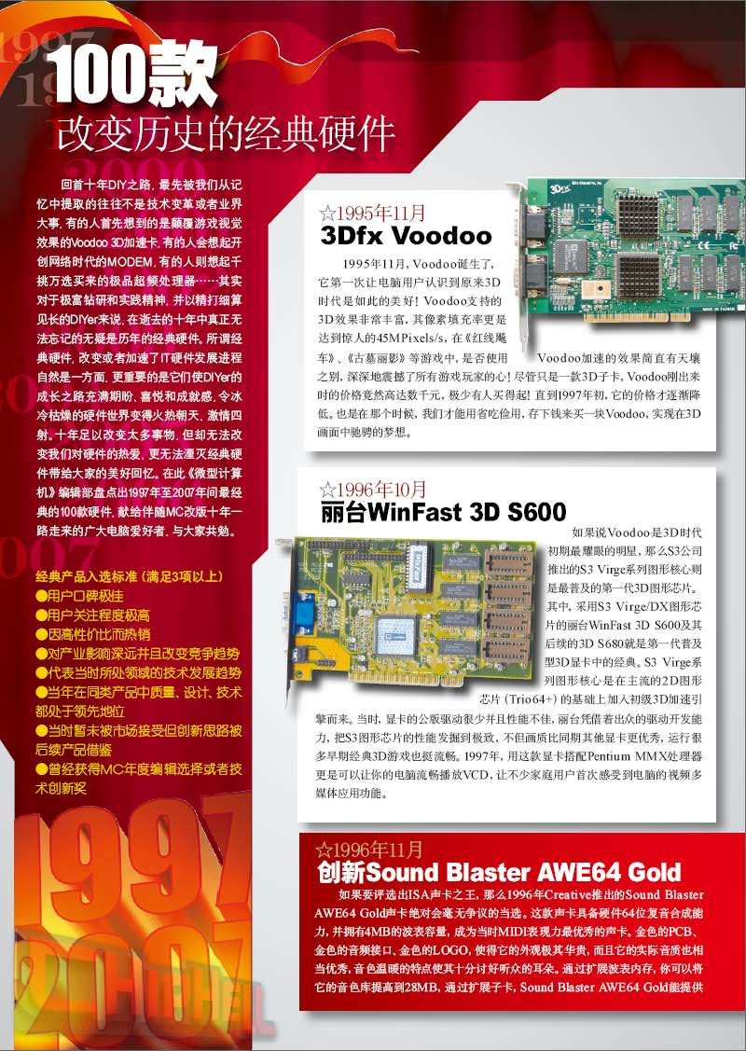

http://www.techcn.com.cn/uploads/200912/12614122242jCGYBYR.gif[**2.jpg**](http://bbs.chiphell.com/attachment.php?aid=36623&nothumb=yes) *(237.97 KB)*

2008-7-9 16:22

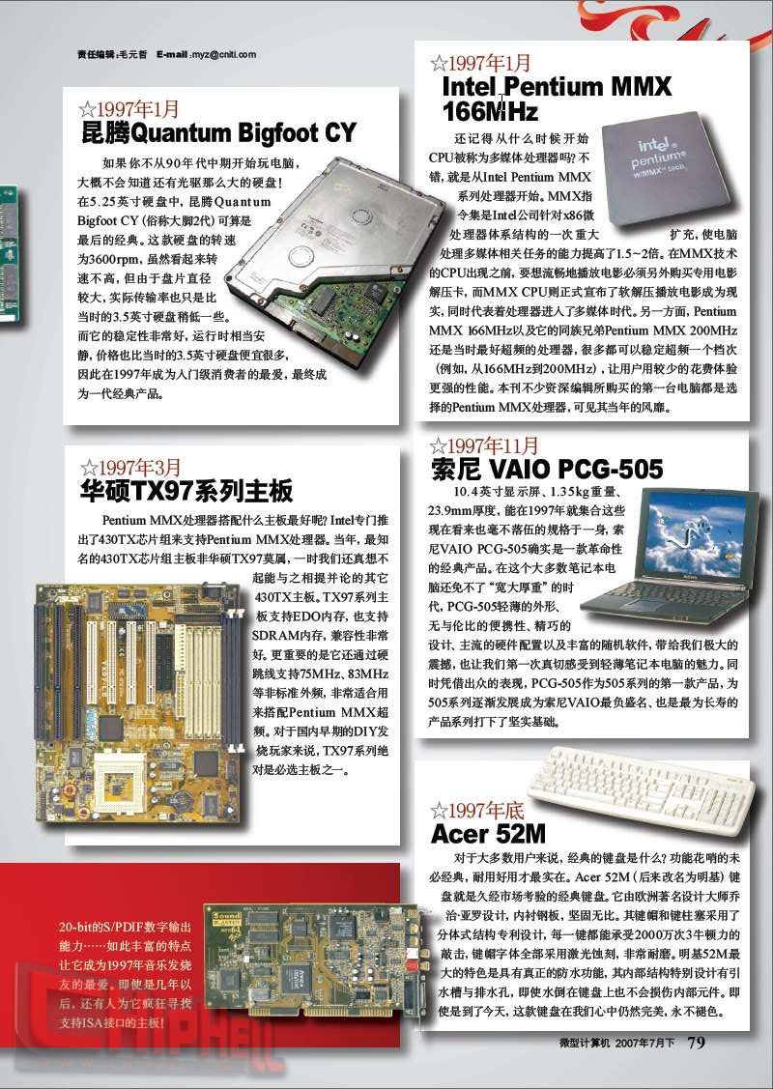

http://www.techcn.com.cn/uploads/200912/12614122242jCGYBYR.gif[**3.jpg**](http://bbs.chiphell.com/attachment.php?aid=36624&nothumb=yes) *(206.64 KB)*

2008-7-9 16:22

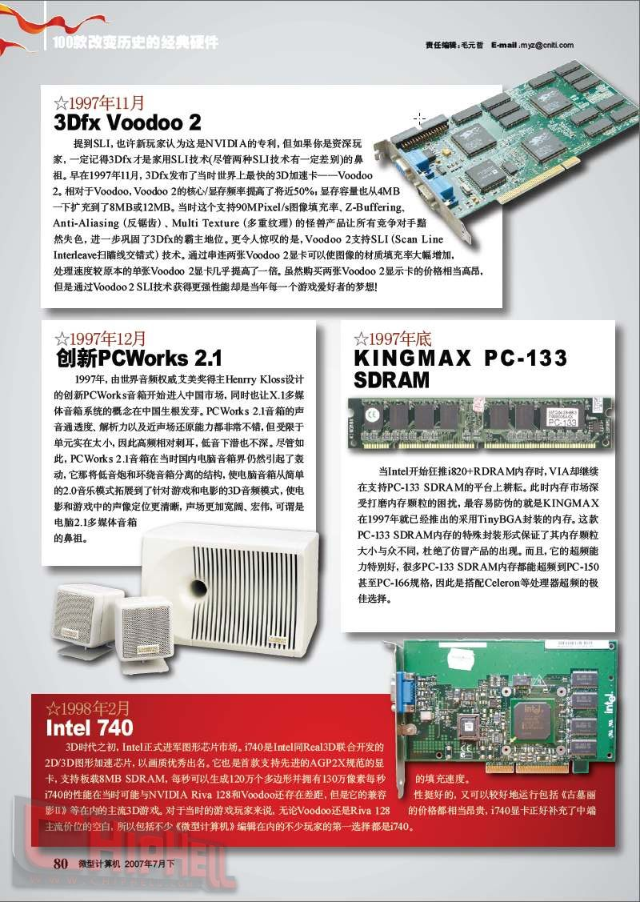

http://www.techcn.com.cn/uploads/200912/12614122242jCGYBYR.gif[**4.jpg**](http://bbs.chiphell.com/attachment.php?aid=36625&nothumb=yes) *(223.38 KB)*

2008-7-9 16:22

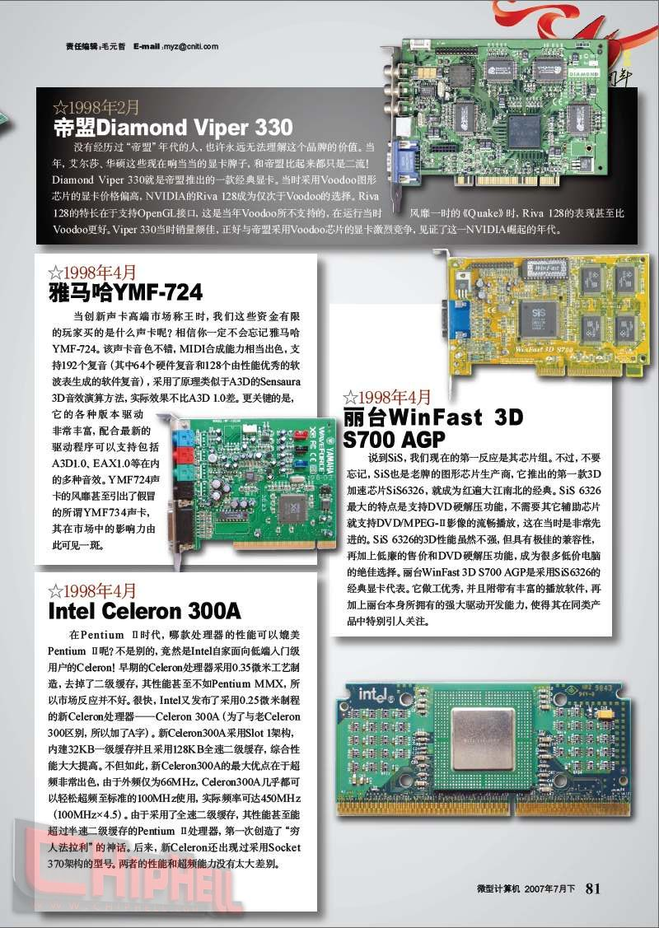

http://www.techcn.com.cn/uploads/200912/12614122242jCGYBYR.gif[**5.jpg**](http://bbs.chiphell.com/attachment.php?aid=36626&nothumb=yes) *(223.11 KB)*

2008-7-9 16:22

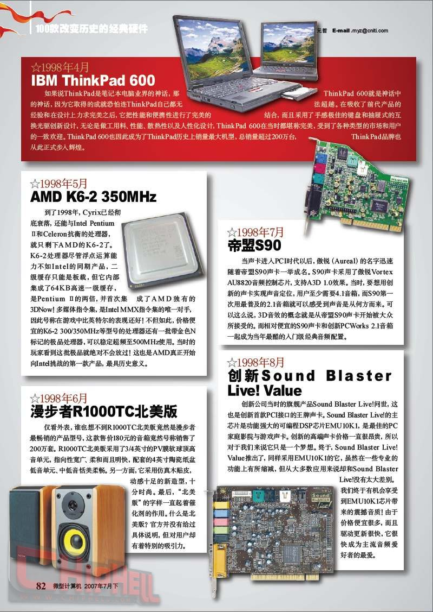

http://www.techcn.com.cn/uploads/200912/12614122242jCGYBYR.gif[**6.jpg**](http://bbs.chiphell.com/attachment.php?aid=36627&nothumb=yes) *(206.08 KB)*

2008-7-9 16:22

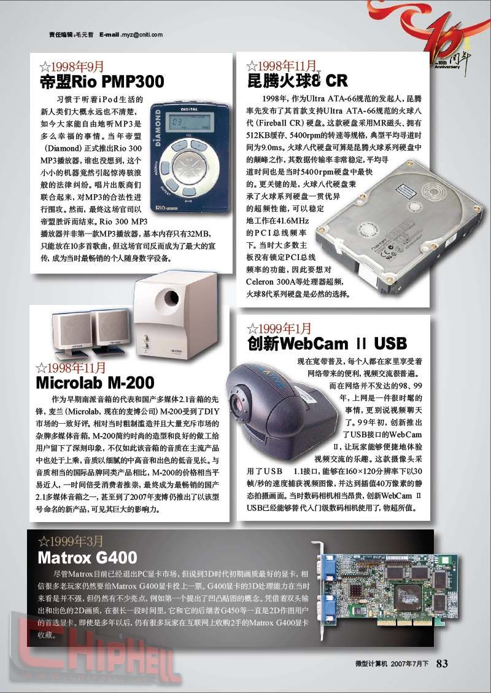

http://www.techcn.com.cn/uploads/200912/12614122242jCGYBYR.gif[**7.jpg**](http://bbs.chiphell.com/attachment.php?aid=36628&nothumb=yes) *(205.88 KB)*

2008-7-9 16:22

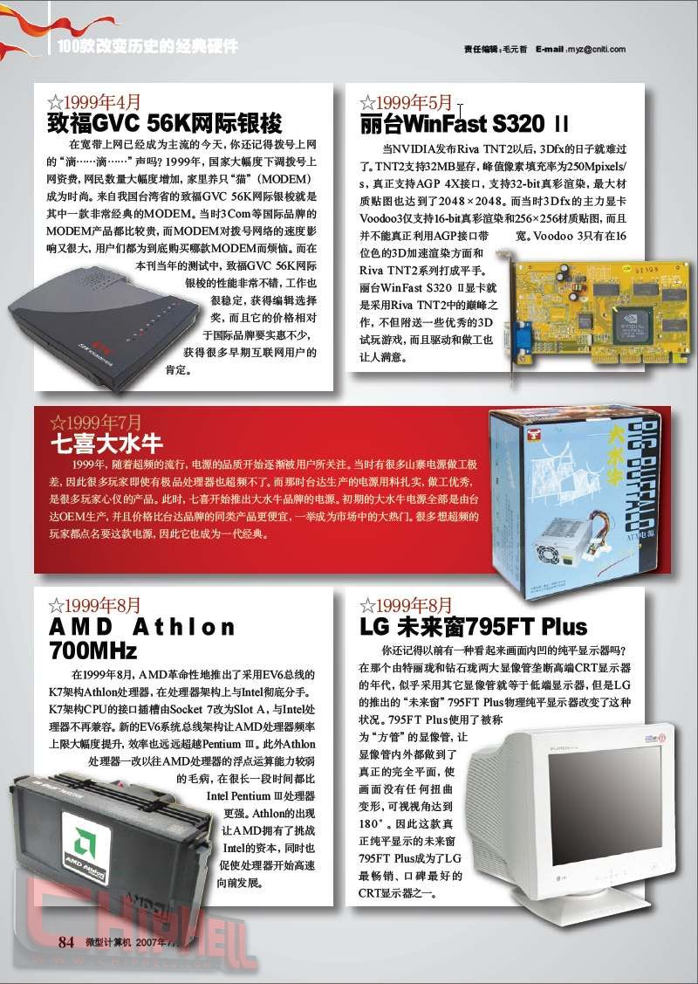

http://www.techcn.com.cn/uploads/200912/12614122242jCGYBYR.gif[**8.jpg**](http://bbs.chiphell.com/attachment.php?aid=36629&nothumb=yes) *(228.29 KB)*

2008-7-9 16:22

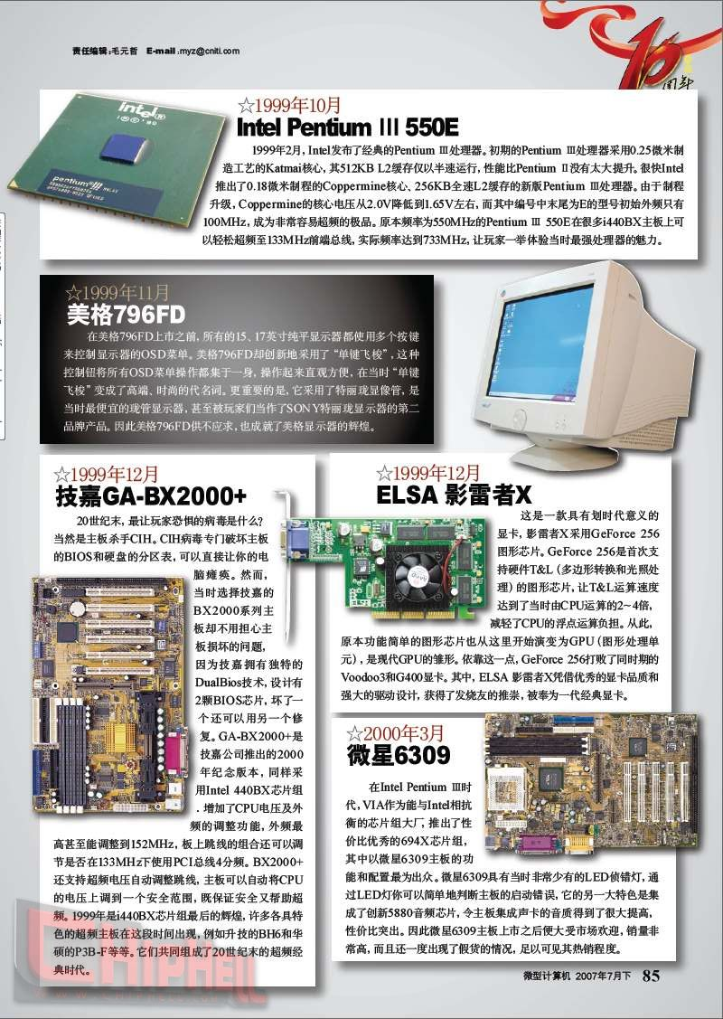

http://www.techcn.com.cn/uploads/200912/12614122242jCGYBYR.gif[**9.jpg**](http://bbs.chiphell.com/attachment.php?aid=36630&nothumb=yes) *(204.85 KB)*

2008-7-9 16:22

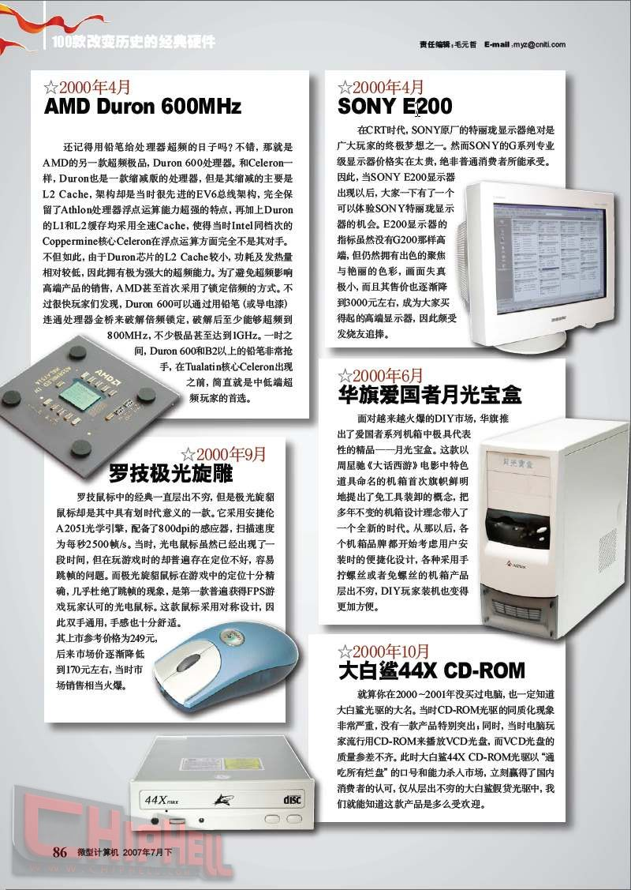

http://www.techcn.com.cn/uploads/200912/12614122242jCGYBYR.gif[**10.jpg**](http://bbs.chiphell.com/attachment.php?aid=36631&nothumb=yes) *(194.56 KB)*

2008-7-9 16:22

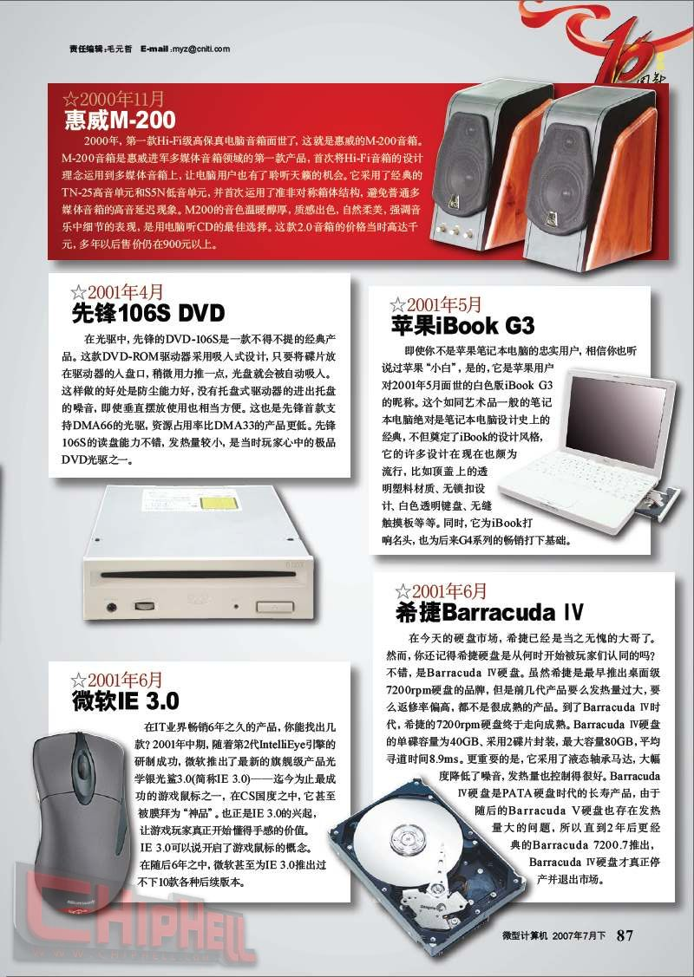

http://www.techcn.com.cn/uploads/200912/12614122242jCGYBYR.gif[**11.jpg**](http://bbs.chiphell.com/attachment.php?aid=36632&nothumb=yes) *(219.02 KB)*

2008-7-9 16:22

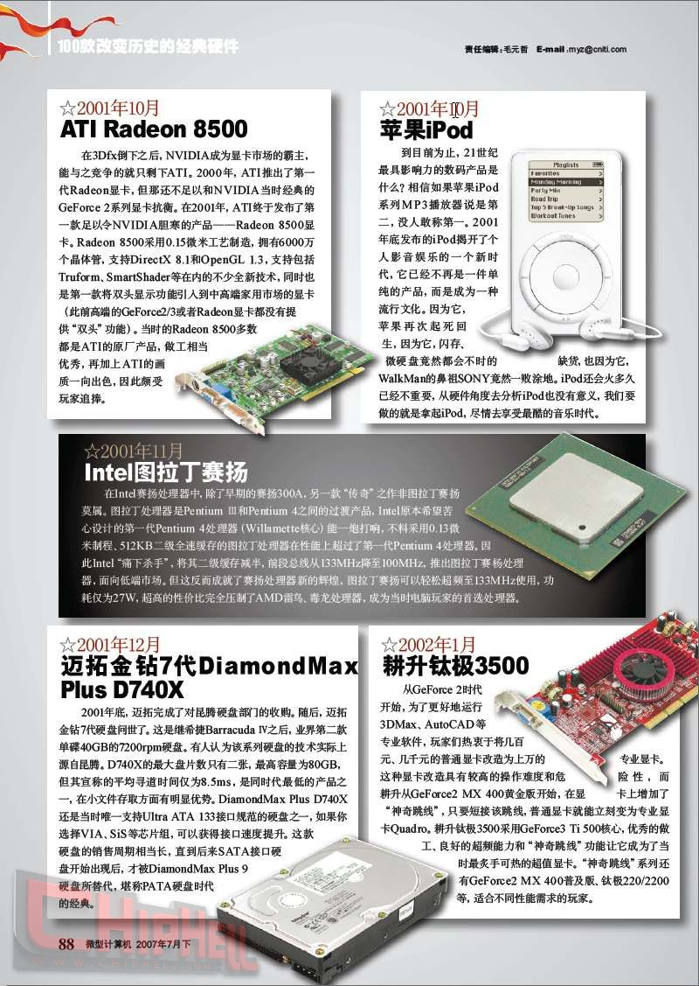

http://www.techcn.com.cn/uploads/200912/12614122242jCGYBYR.gif[**12.jpg**](http://bbs.chiphell.com/attachment.php?aid=36633&nothumb=yes) *(215.79 KB)*

2008-7-9 16:22

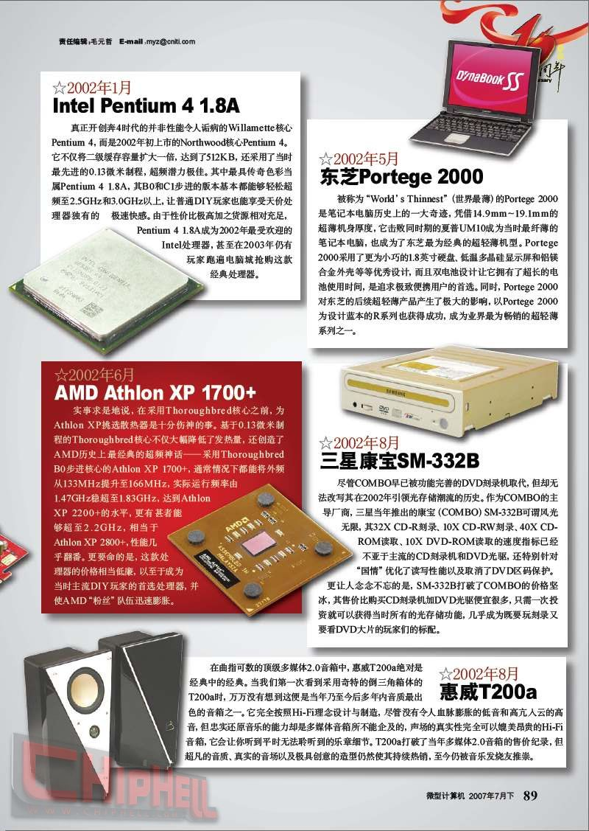

http://www.techcn.com.cn/uploads/200912/12614122242jCGYBYR.gif[**13.jpg**](http://bbs.chiphell.com/attachment.php?aid=36634&nothumb=yes) *(230.73 KB)*

2008-7-9 16:22

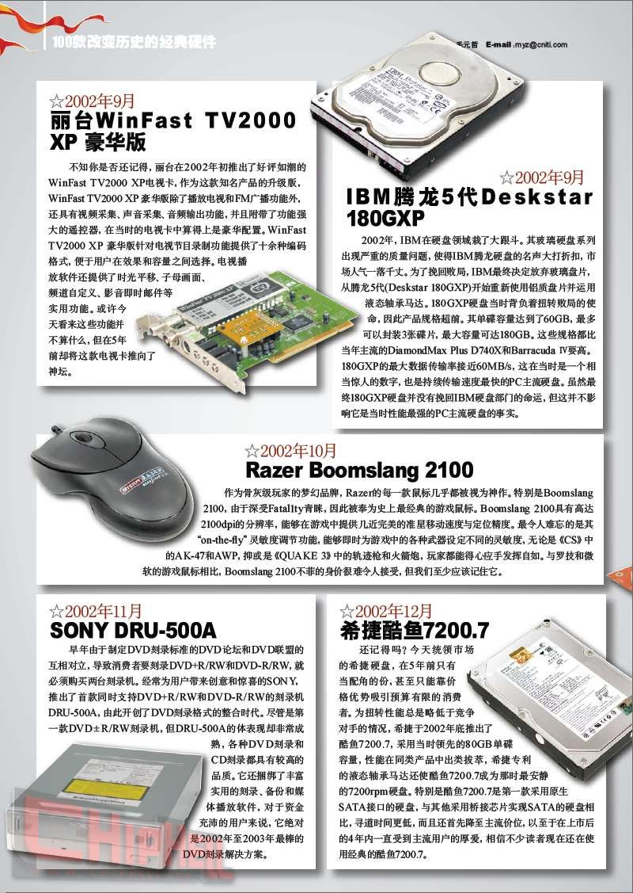

http://www.techcn.com.cn/uploads/200912/12614122242jCGYBYR.gif[**14.jpg**](http://bbs.chiphell.com/attachment.php?aid=36635&nothumb=yes) *(219.16 KB)*

2008-7-9 16:22

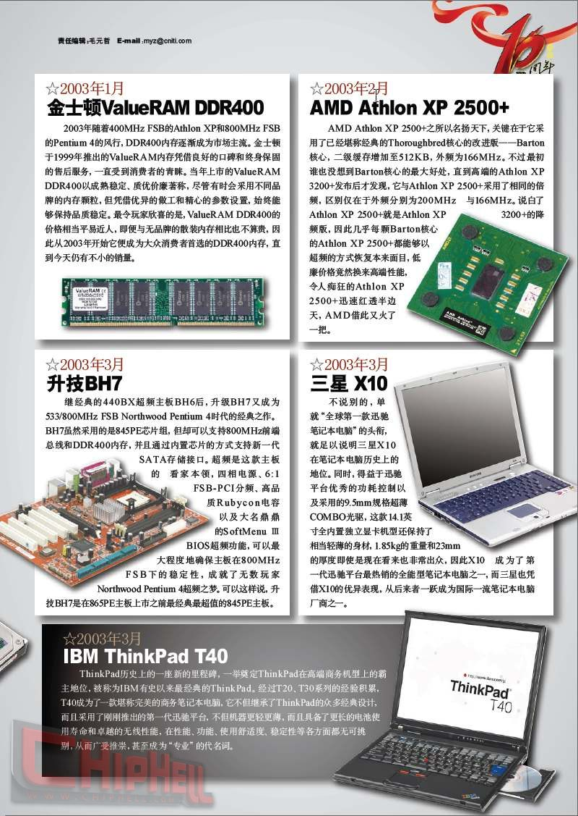

http://www.techcn.com.cn/uploads/200912/12614122242jCGYBYR.gif[**15.jpg**](http://bbs.chiphell.com/attachment.php?aid=36636&nothumb=yes) *(191.12 KB)*

2008-7-9 16:22

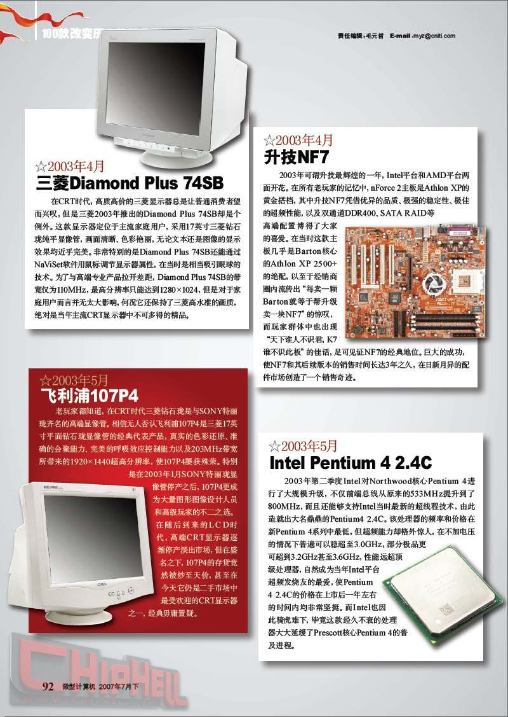

http://www.techcn.com.cn/uploads/200912/12614122242jCGYBYR.gif[**16.jpg**](http://bbs.chiphell.com/attachment.php?aid=36637&nothumb=yes) *(230.69 KB)*

2008-7-9 16:22

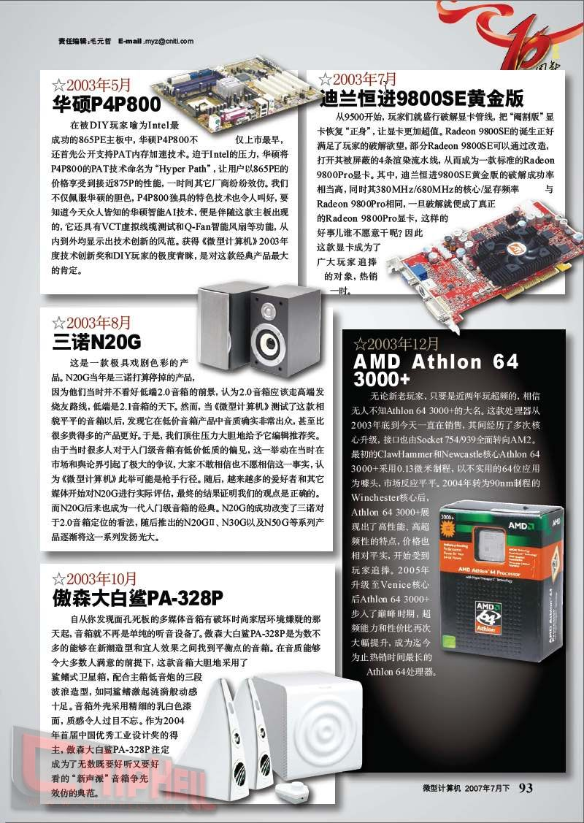

http://www.techcn.com.cn/uploads/200912/12614122242jCGYBYR.gif[**17.jpg**](http://bbs.chiphell.com/attachment.php?aid=36638&nothumb=yes) *(210.76 KB)*

2008-7-9 16:22

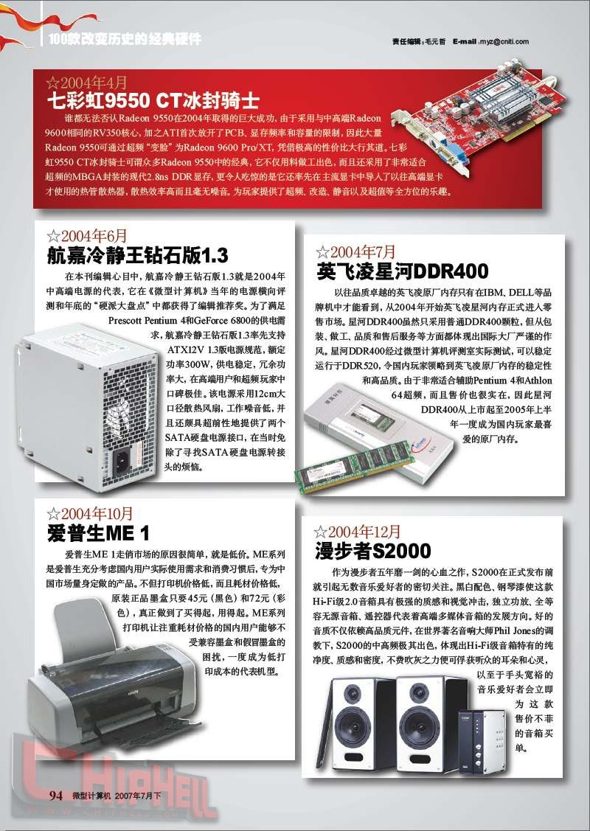

http://www.techcn.com.cn/uploads/200912/12614122242jCGYBYR.gif[**18.jpg**](http://bbs.chiphell.com/attachment.php?aid=36639&nothumb=yes) *(224.76 KB)*

2008-7-9 16:22

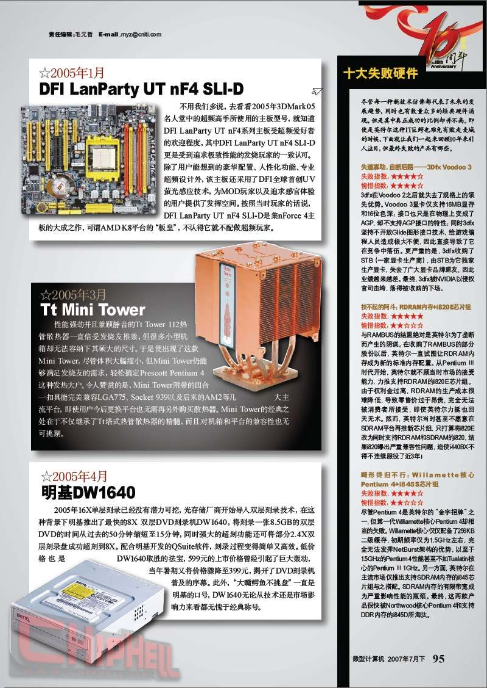

http://www.techcn.com.cn/uploads/200912/12614122242jCGYBYR.gif[**19.jpg**](http://bbs.chiphell.com/attachment.php?aid=36640&nothumb=yes) *(212.84 KB)*

2008-7-9 16:22

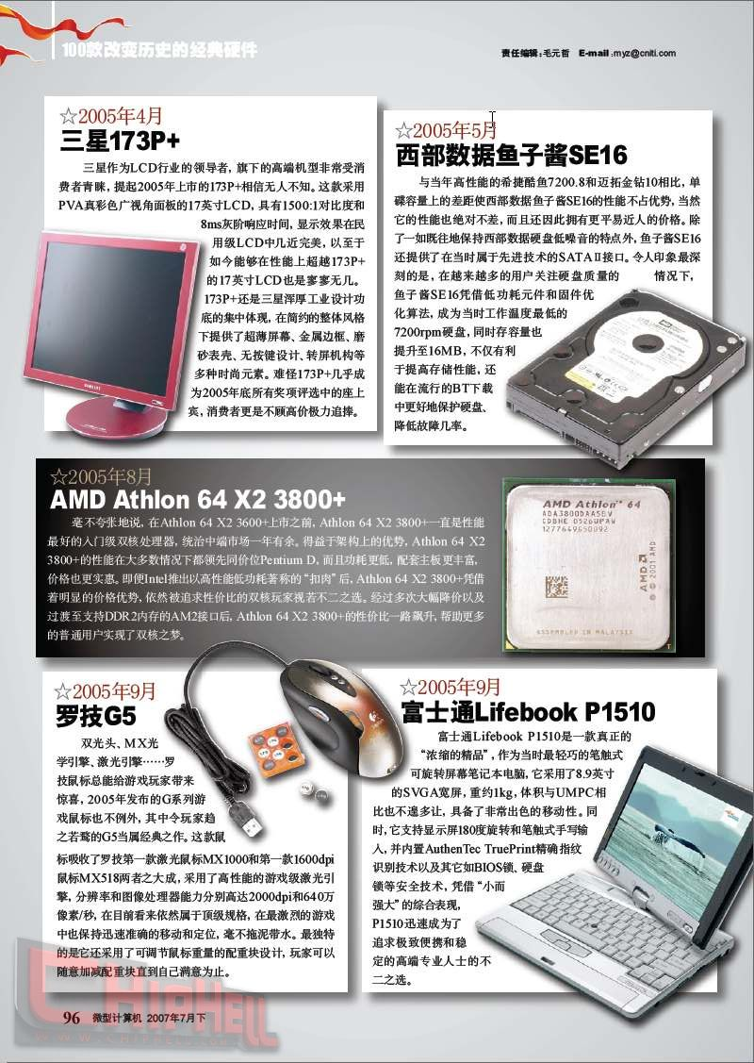

http://www.techcn.com.cn/uploads/200912/12614122242jCGYBYR.gif[**20.jpg**](http://bbs.chiphell.com/attachment.php?aid=36641&nothumb=yes) *(217.9 KB)*

2008-7-9 16:22

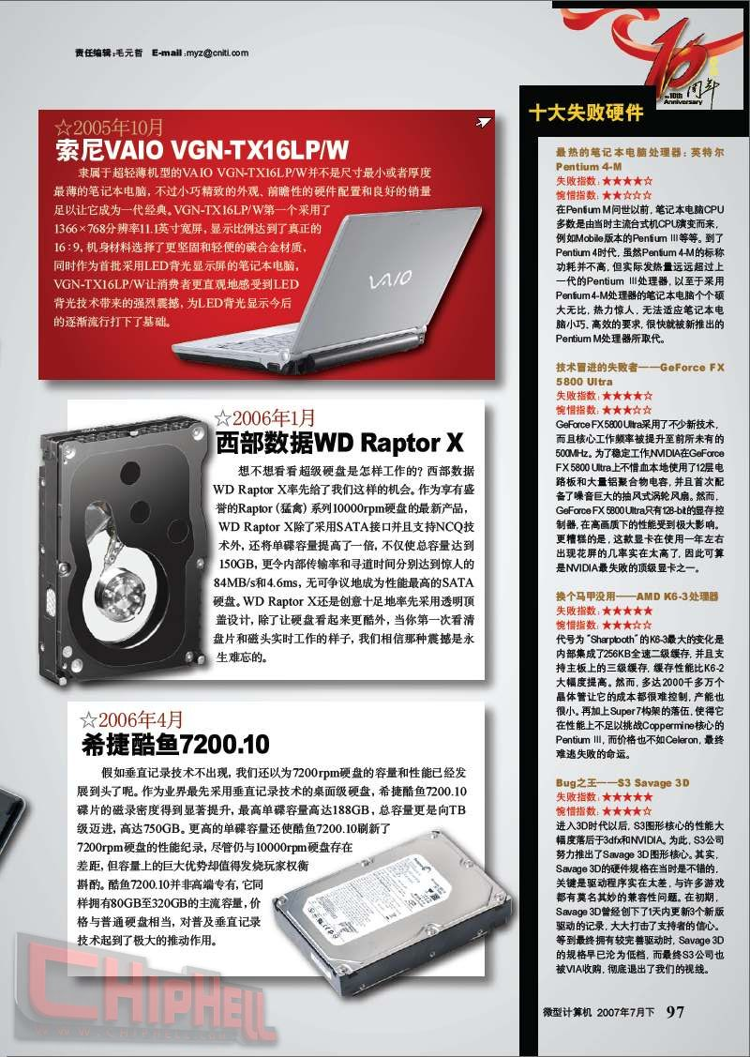

http://www.techcn.com.cn/uploads/200912/12614122242jCGYBYR.gif[**21.jpg**](http://bbs.chiphell.com/attachment.php?aid=36642&nothumb=yes) *(226.43 KB)*

2008-7-9 16:22

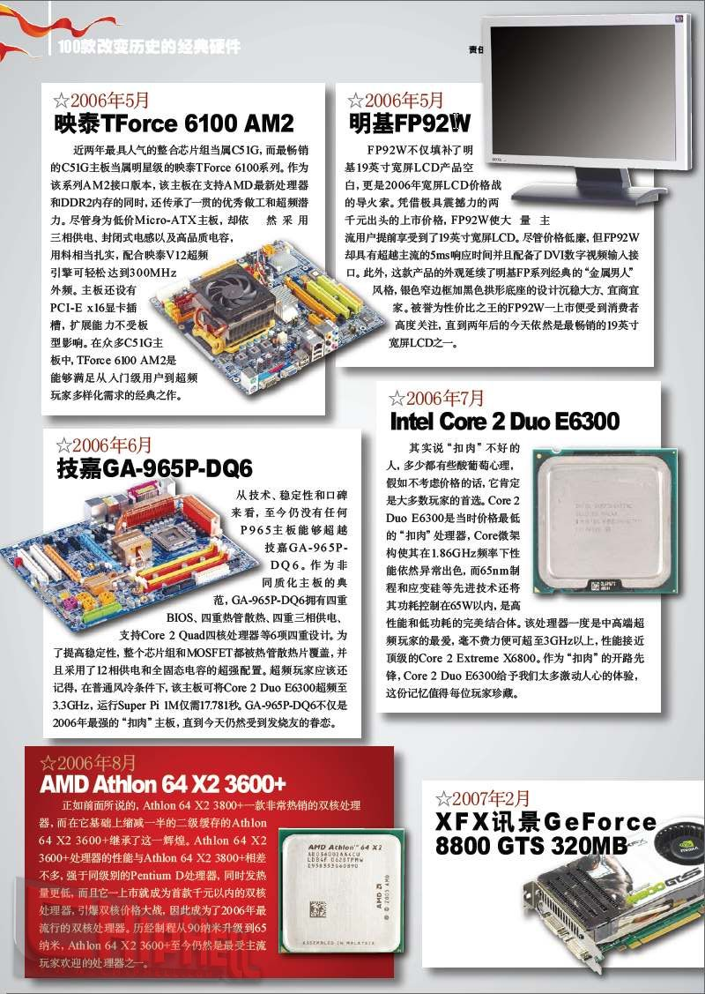

http://www.techcn.com.cn/uploads/200912/12614122242jCGYBYR.gif[**22.jpg**](http://bbs.chiphell.com/attachment.php?aid=36643&nothumb=yes) *(247.36 KB)*

2008-7-9 16:22

